Mohamed Elsyed Galal ***Name /***

***B.N /***  669

***DATE /*** 9/6/2021

***TOPIC /*** CORONA VIROUS

## SCREENSHOTS /

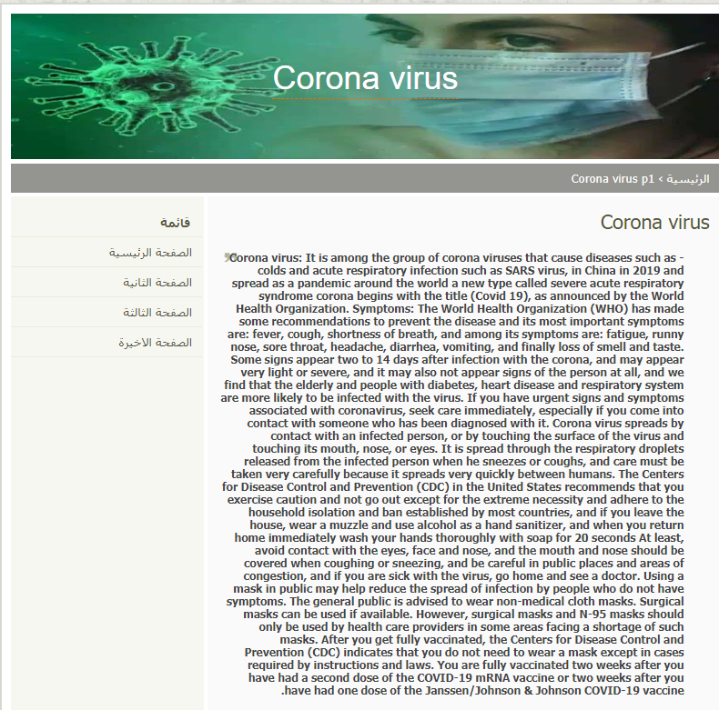

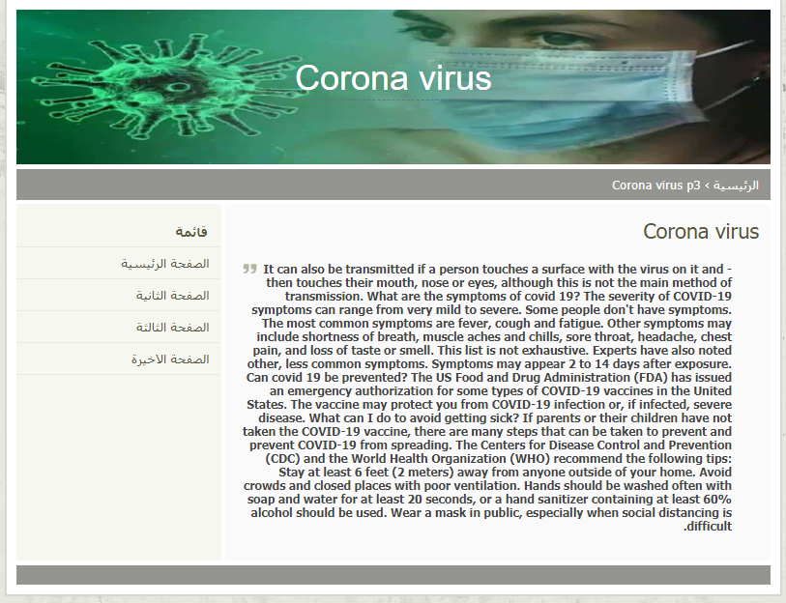

## SOURCE CODE :

